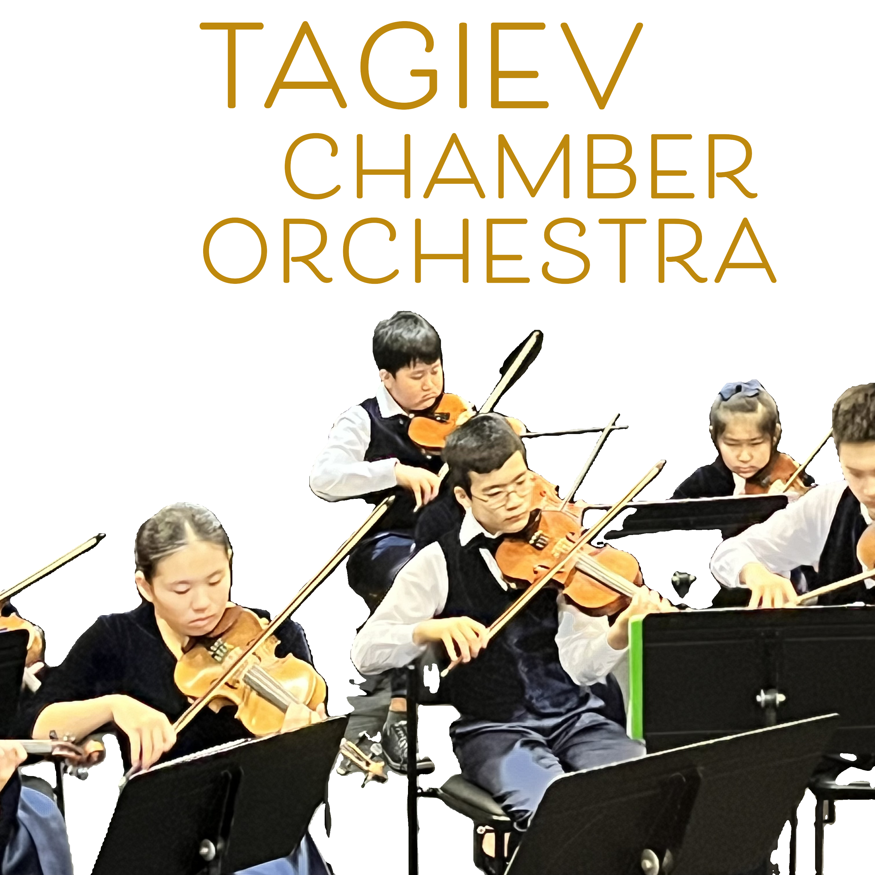

Celebrating Music: The Tagiev Youth Chamber Orchestra Concert

Last weekend, the air at St. Peters Lutheran College was filled with the enchanting sounds of the Tagiev Youth Chamber Orchestra. Under the insightful direction of Emin Tagiev, the concert showcased the incredible talent of Australia’s youth musicians. It was not just an ordinary performance; it was a glimpse into the future of music, embodying the passion and potential of young artists.

Emin Tagiev is a name synonymous with fostering musical talent in our community. He not only leads the Tagiev Youth Chamber Orchestra but is also the visionary behind Brisbane’s first Youth Music International Competition, an annual event that celebrates and promotes the achievements of young musicians across Australia. This initiative not only gives them a platform to shine but also inspires creativity and collaboration among emerging artists.

Exciting news lies ahead for the Tagiev Youth Chamber Orchestra! In December 2024, they will embark on a student exchange program to Germany. This trip represents a remarkable opportunity for the young musicians to perform internationally and learn from esteemed teachers like Stefan Kelber and Ulla Benz . These masterclasses will provide invaluable experiences, helping them refine their skills and musicianship.

Past winners of the Youth Music International Competition will be part of this tour, bringing together diverse talents from around Australia. The chance to perform and collaborate with other talented musicians in a global setting is a dream come true for many and highlights the importance of international cultural exchange in music.

As attendees of the concert left the hall, it was clear that the energy and enthusiasm displayed would resonate long after the final notes faded. The passion for music and the commitment to nurturing the next generation of musicians were palpable, reminding us all of the profound role that music plays in our lives.

The journey ahead for the Tagiev Youth Chamber Orchestra is not just about music; it’s about connection, growth, and the joy of sharing art across borders. We can’t wait to see how their experiences in Germany will shape their future performances and contribute to the vibrant tapestry of youth music in Australia.

As we support these talented musicians, let’s celebrate their achievements and look forward to the wonderful impact that music will continue to have on our lives and communities. Stay tuned for more updates on their journey and the exciting future of youth music!

